Defect Reports for HealthCare website
Defect Report 1
Defect identifier B_001
- DEFECT SUMMARY :- System accepts invalid name (numeric/special characters) in the name field of form.
- TEST ID :- FS_03
- TEST CASE NAME :- Name Field Validation
- MODULE NAME :- Forms & Submissions
- REPRODUCIBLE :- YES
- SEVERITY :- Medium
- PRIORITY :- Medium
- RAISED BY :- Pragati
- ASSIGNED TO :- Developer Team Lead
- DATE OF ASSIGNMENT :- 01/09/2025
- STATUS :- PENDING
- SNAP SHOTS :- [Attach screenshot showing invalid name entered and accepted]
- FIXED BY :- Developer
- DATE OF FIXING :- NA

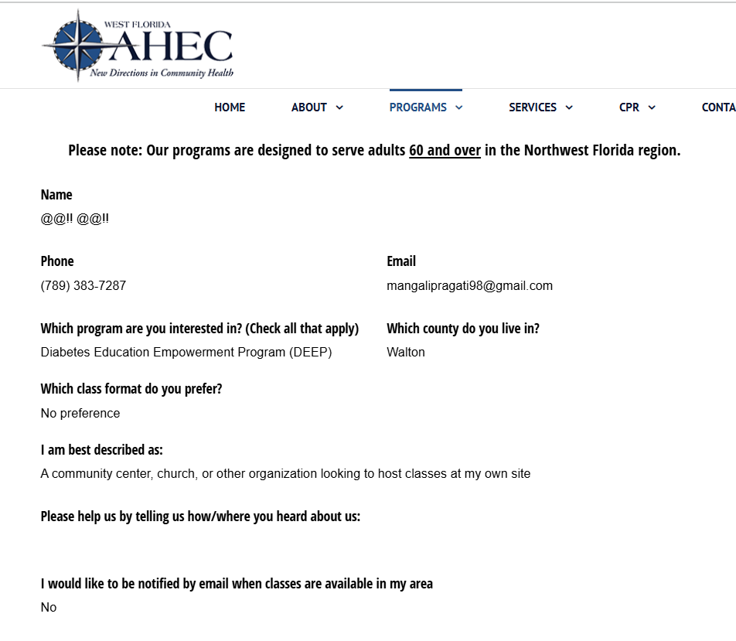

Defect Report 2
Defect identifier B_002
- DEFECT SUMMARY :- User did not receive confirmation email after submitting the form.
- TEST ID :- FS_07
- TEST CASE NAME :- Check Conformation Mail
- MODULE NAME :- Forms & Submissions
- REPRODUCIBLE :- YES
- SEVERITY :- Medium
- PRIORITY :- High
- RAISED BY :- Pragati
- ASSIGNED TO :- Developer Team Lead
- DATE OF ASSIGNMENT :- 01/09/2025
- STATUS :- PENDING
- SNAP SHOTS :- [Attach screenshot of form submission with no confirmation mail received]
- FIXED BY :- Developer
- DATE OF FIXING :- NA

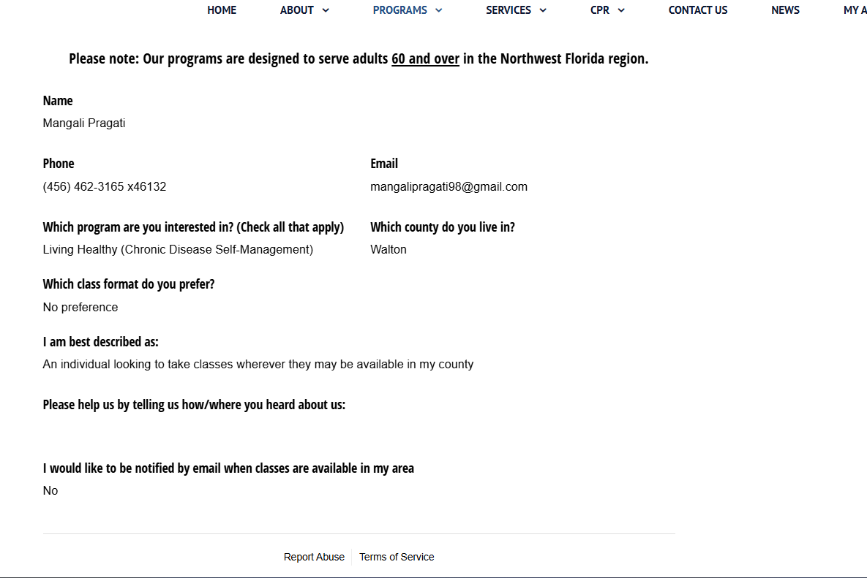

Defect Report 3
Defect identifier B_003
- DEFECT SUMMARY :- Message box accepts long strings (>500 characters) without showing an error.
- TEST ID :- FS_10
- TEST CASE NAME :- Large Input Handling
- MODULE NAME :- Forms & Submissions
- REPRODUCIBLE :- YES
- SEVERITY :- Medium
- PRIORITY :- Medium
- RAISED BY :- Pragati
- ASSIGNED TO :- Developer Team Lead
- DATE OF ASSIGNMENT :- 01/09/2025
- STATUS :- PENDING
- SNAP SHOTS :- [Attach screenshot of message box with >500 characters accepted]
- FIXED BY :- Developer
- DATE OF FIXING :- NA

